THE PUMA PRODUCTION MANAGER BOOTCAMP
Sunday 7 & Monday 8 September 2014
Best Western Country House Hotel, Thornhill, Cardiff

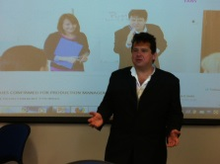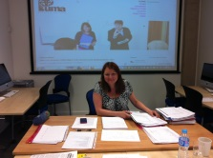

TWO DAYS of intensive, interactive and inspirational practical training for Production staff and freelancers.

Whether you are looking to step up into Production Management, or refresh your skills and knowledge this is an opportunity to develop abilities and job prospects.  The cost includes all training materials, food and accommodation and use of the hotel’s facilities, crèche facility available upon request, transport to and from Cardiff City Centre if required. | Content:  - The Changing Demands of the PM in relation to Business and Finance  - Working in a Multi-platform World  - The Law, Logistics and Management  - Industry Guests, Case Studies and Budgeting Exercises

BURSARIES ARE AVAILABLE FOR UP TO 80% OF THE COST, INCLUDING TRAVEL THROUGH
- CREATIVE SKILLSET CYMRU: http://creativeskillset.org/who_we_help/creative_professionals/funding_training_wales/cymru_freelance_fund
- Reduced fee for those who do not qualify for a bursary.

Programme details on http://www.pumaeventsandtraining.co.uk/2014-production-courses.html

07979 917 768 (Christine Pyke) 07976 895 946 (Ric Michael) www.pumaeventsandtraining.co.uk @PumaEvents

